

**INTERNATIONAL SCHOOL**

**CAPSTONE PROJECT 1**

**CMU-CS 246**

**USER INTERFACE DESIGN DOCUMENT**

Version: 1.1

**CALCULATOR SYSTEM – CS**

**Mentor: Nguyen Dang Quang Huy**

***Team Member*:**

**Phan Quang Trung**

**Pham Ngoc Trung**

**Nguyen Quang Thong**

**Tran Quoc Hoang**

**Mai Hoang Tung**

**Approved by Nguyen Dang Quang Huy**

**UserInterface Review Panel Representative:**

Name Signature Date

**Project 1- Mentor:**

Name Signature Date

Da Nang, 1/2024

**PROJECT INFORMATION**

|  |  |
| --- | --- |
| **Project Acronym** | CS |
| **Project Title** | Calculator System | | | |
| **Start Date** | Jan 25, 2024 | **End Date** | Jan 31, 2024 | |
| **Lead Institution** | International School, Duy Tan University | | | |
| **Team Member** | **Name** | **Email** | | **Phone** |
| 28211148230 | Phan Quang Trung | Phanquangtrung30042004@gmail.com | | 0708110429 |
| 28214305594 | Pham Ngoc Trung | phamngoctrungqb@gmail.com | | 0914223472 |
| 28211105451 | Nguyen Quang Thong | dn7110994@gmail.com | | 0775506786 |
| 28219020521 | Tran Quoc Hoang | hoanglucky321@gmail.com | | 0981553208 |
| 28214300656 | Mai Hoang Tung | tunghoang1707@gmail.com | | 0947987858 |

**PROJECT PLAN DOCUMENT**

|  |  |  |  |
| --- | --- | --- | --- |
| **Document Title** | User Interface Document | | |
| **Author(s)** | Team 3 | | |
| **Date** | Sep 25th, 2024 | **File name:** | USER INTERFACE DESIGN DOCUMENT by Team3.docx |
| **URL** | https://drive.google.com/drive/folders/1VBFtGWBCnRpGMqdGtfbFpeBkVWMBZLLa?fbclid=IwAR1yayEYbziiTyqEZzhwuKG9GyvX8ZI8rmHJ_P-HtsoFvXtxV--5uHZpb4c | | |
| **Access** | Project and CMU Program | | |

**SIGNATURE**

**Document Approvals:** The following signatures are required for approval of this document.

|  |  |  |  |
| --- | --- | --- | --- |
| **Mentor** | **Nguyen Dang Quang Huy** | **Signature:** |  |
| **Date:** |  |
| **Project Manager** | **Nguyen Quang Thong** | **Signature:** |  |
| **Date:** |  |
| **Team member(s)** | **Mai Hoang Tung** | **Signature:** |  |
| **Date:** |  |
| **Tran Quoc Hoang** | **Signature:** |  |
| **Date:** |  |
| **Pham Ngoc Trung** | **Signature:** |  |
| **Date:** |  |
|  | **Phan Quang Trung** | **Signature:** |  |
|  |  | **Date:** |  |

**DOCUMENT HISTORY**

|  |  |  |  |
| --- | --- | --- | --- |
| **Version** | **Person** | **Date** | **Description** |
| 1.0 | Phan Quang Trung | Jan 23th, 2024 | Basic computer interface design |
| 1.1 | Phan Quang Trung | Jan 25th, 2024 | Update function when dividing by zero to report an error |
| 1.2 | Phan Quang Trung | Jan 28th, 2024 | Update function for Mode button(%) |
| 1.2 | Phan Quang Trung | Jan 31th, 2024 | Fixed and compele. |

# INTRODUCTION

## PURPOSE

* Document the design of user interface of functions of the Calculator System
* Be the primary document driving the implementation of the user interfaces.
* Introduce interface design for the reader. Including the background, content information display, command buttons

1. **SCOPE**

## • Interface design documents for the functions of the Computer System

## • Is the primary document that drives the implementation of user interfaces.

## • Introduces basic computer interface design to readers. Includes background image, results information display, command button for calculation.

## SCOPE

This document is intended for the following audiences:

* Technical reviewers including:
* Project Manager
* Product owner
* Implementers, including:
  + The team developers.
  + Testers.

# LIST OF USER INTERFACE

## BUSINESS FUNCTION DIAGRAM:

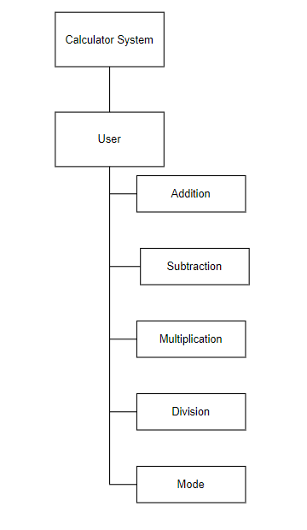

*Figure 1: Business Function diagram*

## WEB APP:

|  |  |  |
| --- | --- | --- |
| **User Interface ID** | **UI Name** | **Description** |
| UI-01 | Home Page | The home page allows users to enter numbers and select the calculations they want to perform |
| UI-02 | Addition Page | This page is for user to perform addition calculations |
| UI-03 | Subtraction Page | This page is for user to perform subtraction calculations |
| UI-04 | Multiplication Page | This page is for user to perform multiplication calculations |
| UI-05 | Division Page | This page is for user to perform division calculations |
| UI-06 | Mode Page | This page is for user to perform mode calculations(The return value is the remainder of division |

*Table 1: List of Interface*

# DESCRIBE USER INTERFACE

## HOME PAGE

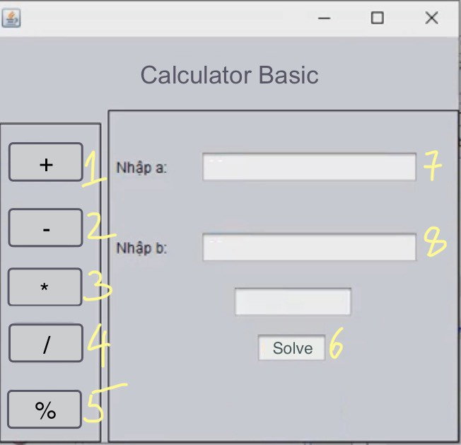

*Table 2: Describe User Interface Homepage*

|  |  |  |  |
| --- | --- | --- | --- |
| **ID** | **Condition** | **Control Type** | **Target** |
| 1 | Press | Button | Click to go to the Addition page |
| 2 | Press | Button | Click to go to the Subtraction page |
| 3 | Press | Button | Click to go to the Multiplication page |
| 4 | Press | Button | Click to go to the Division page |
| 5 | Press | Button | Click to go to the Mode page |
| 6 | Press | Button | Click to see solve |
| 7 |  | Label | Enter a |
| 8 |  | Label | Enter b |

## ADDITION PAGE

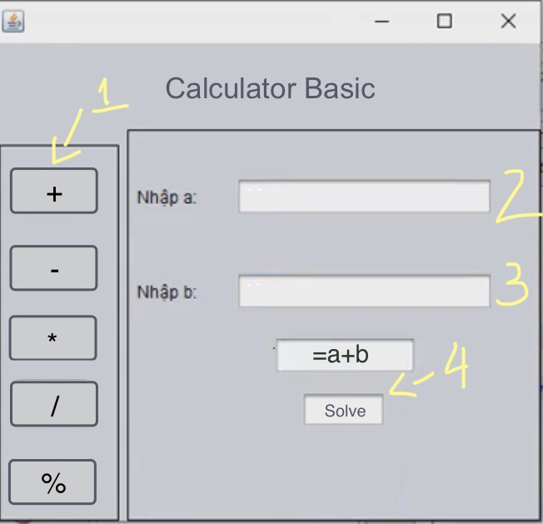

*Table 3 : Describe User Interface Addition page*

|  |  |  |  |
| --- | --- | --- | --- |
| **ID** | **Condition** | **Control Type** | **Target** |
| 1 | Press | Button | Click to go to the Addition page |
| 2 | Enter a number | Lable | Enter A |
| 3 | Enter a number | Lable | Enter B |
| 4 |  | Button | Gets the value of a number used for calculation (solve = a+b) |

## SUBTRACTION PAGE

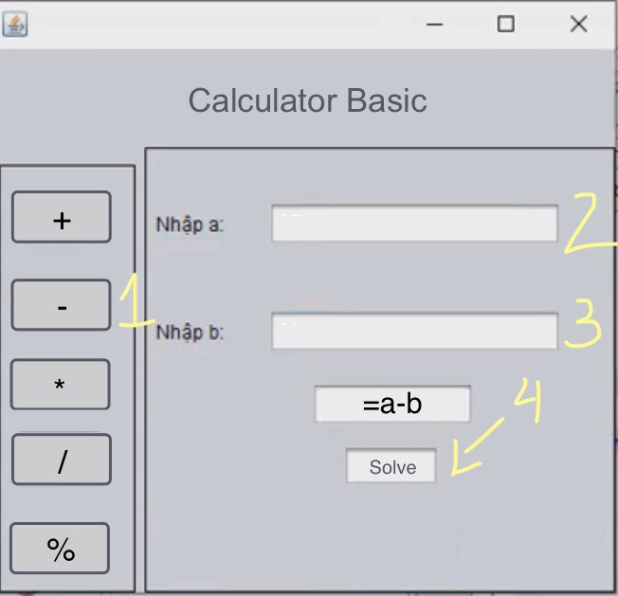

*Table 4 : Describe User Interface Subtraction page*

|  |  |  |  |
| --- | --- | --- | --- |
| **ID** | **Condition** | **Control Type** | **Target** |
| 1 | Press | Button | Click to go to the Subtraction page |
| 2 | Enter a number | Lable | Enter A |
| 3 | Enter a number | Lable | Enter B |
| 4 |  | Button | Gets the value of a number used for calculation (result = a-b) |

## MULTIPLICATION PAGE

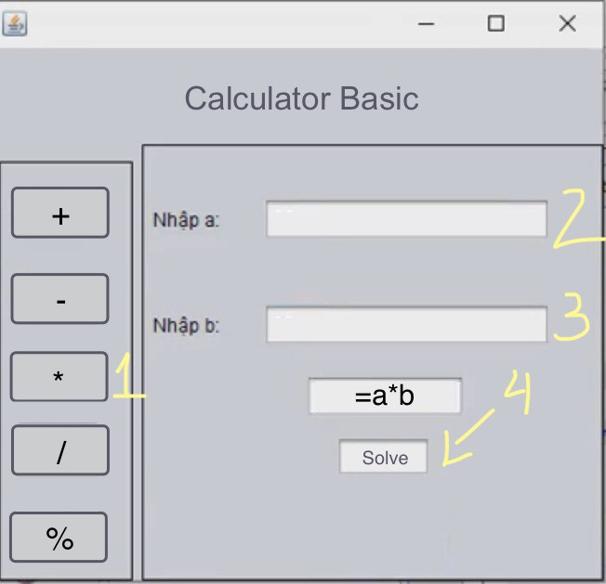

*Table 5 : Describe User Interface Multiplication page*

|  |  |  |  |
| --- | --- | --- | --- |
| **ID** | **Condition** | **Control Type** | **Target** |
| 1 | Press | Button | Click to go to the Multiplication page |
| 2 | Enter a number | Lable | Enter A |
| 3 | Enter a number | Lable | Enter B |
| 4 |  | Button | Gets the value of a number used for calculation (result = a*b) |

## DIVISION PAGE

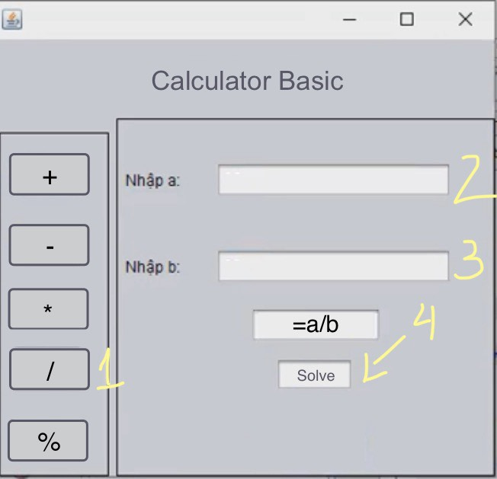

*Table 6 : Describe User Interface Division page*

|  |  |  |  |
| --- | --- | --- | --- |
| **ID** | **Condition** | **Control Type** | **Target** |
| 1 | Press | Button | Click to go to the Division page |
| 2 | Enter a number | Lable | Enter A |
| 3 | Enter a number | Lable | Enter B |
| 4 |  | Button | Gets the value of a number used for calculation (result = a/b) |

## MOD PAGE

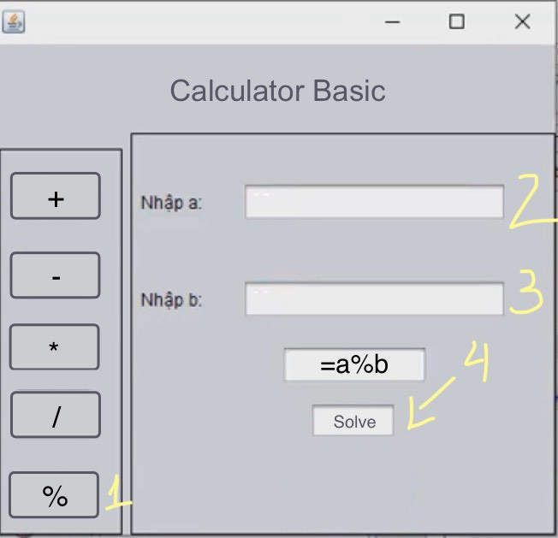

*Table 7 : Describe User Interface Mod page*

|  |  |  |  |
| --- | --- | --- | --- |
| **ID** | **Condition** | **Control Type** | **Target** |
| 1 | Press | Button | Click to go to the Division page |
| 2 | Enter a number | Lable | Enter A |
| 3 | Enter a number | Lable | Enter B |
| 4 |  | Button | Gets the value of a number used for calculation (result = a%b) get only the remainder |